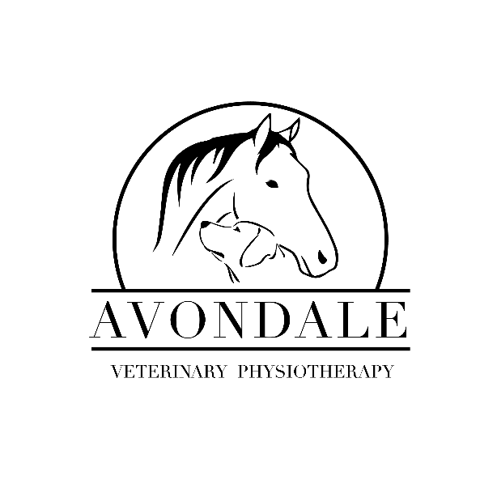

Veterinary referral and consent form

Please ensure this form is completed and returned via email before the first appointment.

Animals will not receive any veterinary physiotherapy without veterinary consent.

Section 1 – To be completed by the owner.

Owner details

Name
Address
Phone
Email

Animal details

Name | Age
Breed
Sex | Neutered (Y/N)
Species
Reason for referral

Veterinary details

Practice name and address
Vets name
Phone
Email

Section 2 – To be completed by the veterinary surgeon.

Medical details

Current condition(s)/diagnosis
Medication
Pre-existing conditions
Any additional comments

I consent to the above-named animal receiving veterinary physiotherapy assessment and treatment, as deemed appropriate, from Aimee Joy of Avondale Veterinary Physiotherapy. I understand that the provision of any indemnity insurance is the responsibility of Avondale Veterinary Physiotherapy, and that the animal may be referred back to the practice. If this form is not completed and returned it is assumed that permission is granted unless otherwise implicitly stated.

Name
Signature
Date

