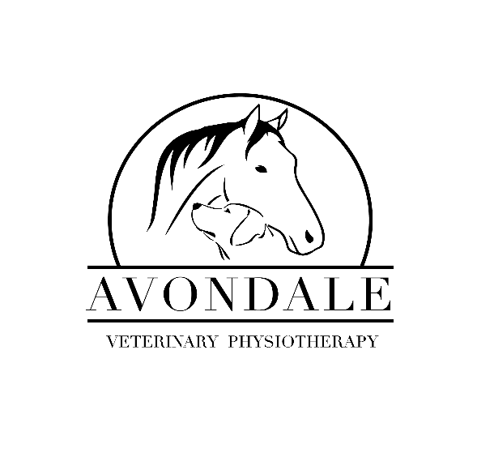

Avondale Veterinary Physiotherapy
Terms and Conditions

Please read these terms and conditions carefully before using Avondale Veterinary Physiotherapy.

- Legalities:

By accessing and utilising the services of Avondale Veterinary Physiotherapy you accept and agree to be bound by the terms and conditions of this agreement. In addition, when utilising these services, you shall be subject to any guidelines or rules applicable during the process of this service at the discretion of Avondale Veterinary Physiotherapy. Any participation in this service constitutes acceptance of this agreement.

In accordance with the Veterinary Surgeons Act of 1966, all animals must have veterinary consent prior to their first appointment.
If the animal develops a new condition whilst having therapy for an existing condition, or while having a fitness session, a new veterinary referral may be required before treatment can continue. Failure to provide a new referral at the time of treatment commencement will result in the animal not being seen. Please see the ‘Veterinary Consent and Referral Form’.

- Appointment requirements:

- The owner or a responsible person must be present.
- Please give dogs the opportunity to go to the toilet and empty their bowels prior to the physiotherapy session.
- Please ensure horses are in from pasture and ready for their appointment in a clean, dry state, ideally on hardstanding. Damp coats result in a suboptimal assessment through palpation and may reduce the effectiveness of treatment.
- Please do not feed dogs less than 2 hours before their appointment.
- Please try to avoid booking your horses appointment during feeding times on the yard.
- Horses should not be exercised straight after a treatment so appointments should be booked with this considered.
- All animals are treated with care, respect, and consideration. This may necessitate allowing time for the animal to relax and habituate before any hands-on assessment is initiated.
- Any animal presenting with illness, coughing/sneezing, sickness, diarrhoea, flea infestations or lice will not be treated but the appointment may still be charged for.

- It is the owners/client’s responsibility to notify Avondale Veterinary Physiotherapy if their veterinarian has advised that treatment should be stopped or suspended for any reason.
- Whilst every care will be taken to provide the best possible treatment for the animal, treatments are carried out entirely at the owner’s risk. The registered owner of the animal is fully responsible for the behaviour of themselves and their animal and any event that should arise because of action by said animal at all times. The animal is not the responsibility of Avondale Veterinary Physiotherapy.

- Appointment time:

Whilst Avondale Veterinary Physiotherapy endeavour to arrive punctually for all appointments, any unforeseen circumstances preventing this will be communicated to you (the owner) and if necessary, the appointment will be rescheduled.

- Payment terms:

- Payment is required by cash, PayPal, or BACS at the time of treatment. Card payments and cheques are not currently accepted.
- Avondale Veterinary Physiotherapy reserves the right to pursue any unpaid accounts in any manner that is deemed appropriate. This may include the use of debt collection services or civil proceedings. Any costs incurred by Avondale Veterinary Physiotherapy through recovering unpaid accounts will be passed onto the respective client.
- Failure to comply with the payment terms may result in the withdrawal of service.
- Many pet insurance companies will reimburse costs for veterinary physiotherapy, but owners are advised to check your policy before booking an appointment. For insurance claims Avondale Veterinary Physiotherapy respectfully reminds the owner that the payment terms still apply and that the contract with the insurance company is between the client and the insurance company only. Therefore, payment is required at the time of treatment and accounts from here on are not held open.
- Avondale Veterinary Physiotherapy will ensure that all prospective clients are fully informed and aware on excess travel costs outside a 20-mile radius of Merseyside.

- Cancellation policy:

Avondale Veterinary Physiotherapy understands that there may be extenuating circumstances forcing a client to cancel their appointment. A minimum of 24 hours’ notice is required for cancellations. Full payment is due if less than 24 hours’ notice is given or if the appointment is a ‘no show’.

- Complaints:

Our aim at Avondale Veterinary Physiotherapy is to provide outstanding service. However, should you wish to discuss any problems you may have with our services we ask that you address any issues with Aimee in the first instance.

- Client confidentiality:

The veterinary physiotherapist/client relationship is founded on trust and Avondale Veterinary Physiotherapy will not discuss or disclose any information about a client or animal to any third party without either express or implied consent.

Avondale Veterinary Physiotherapy retain, as our property, all clinical records. Any veterinarian or paraprofessional taking over the case may be forwarded copies of relevant records but only upon the request or consent of the client.

Photos and videos are regularly taken during physiotherapy sessions as a way of monitoring any changes in the animal’s condition. These are occasionally used on the Avondale Veterinary Physiotherapy website and social media page. If you would prefer that these images are not shared, please let Aimee know.

- Data protection:

In holding and using data about clients, owners and animals, Avondale Veterinary Physiotherapy will comply with the provisions of the General Data Protection Regulation (GDPR) and the Data Protection Act 2018. In instructing us to treat your animal, you authorise us to use that data in the course of the work that we do for you.

We will, where specifically required, pass on details of clinical histories and case records relating to yourself or your animal to insurers. We will not divulge your details to any other agencies except for debt collection purposes. The information gathered by Avondale Veterinary Physiotherapy is used for the purposes of providing veterinary physiotherapy treatment and to contact you (the owner) regarding arranging appointments and sending treatment notes. Your animal’s veterinarian will also be contacted occasionally to discuss progress/request access to medical records.

